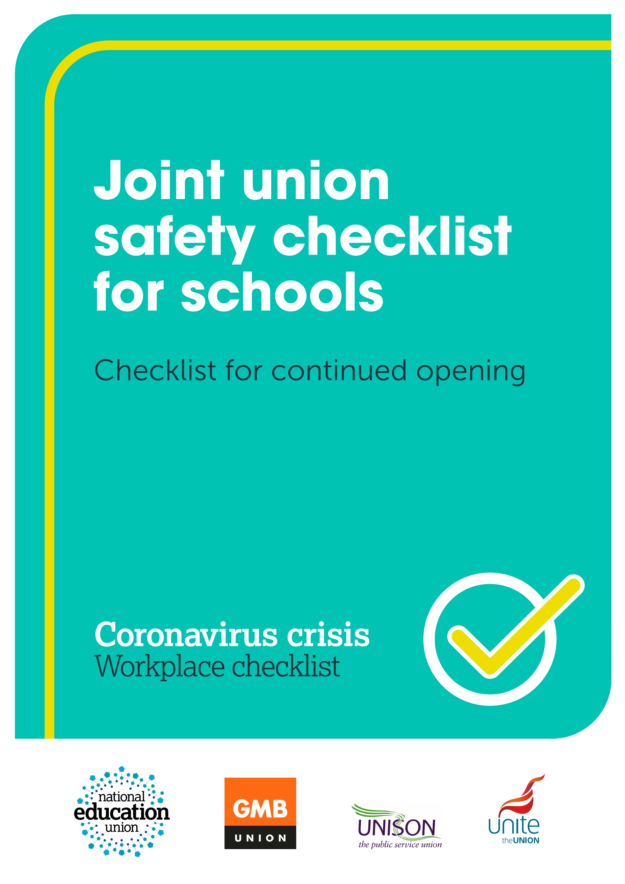

This checklist has been issued by the Joint Unions (GMB, NEU, UNISON and UNITE) for use from November 2020 onwards in schools.

This checklist sets out enhanced measures
Faced with this on-going situation, the Joint Unions want to support schools in remaining safely open in conjunction with Welsh Government Guidance.
Developments since schools fully re-opened in September include:
- Increased case rates in Wales with additional restrictions imposed in many areas followed by the national firebreak during the autumn term.
- Evidence that case rates are much higher among young people of mandatory school age than was previously realised.
- Official acceptance by Welsh Government and Public Health Wales of the role of airborne transmission, particularly in poorly ventilated places where groups of people spend long periods of time together (this crucial new information is particularly important for schools); and
- Significant workload problems in many schools.
Where schools remain open, the Joint Unions are calling upon schools to implement, and maintain, the following enhanced measures to keep them safely open for both staff and pupils and prevent workload spiralling out of control. Please discuss these measures with school leaders. They should also be adhered to by external contractors, including those involved in catering and cleaning. This is very much a live document which we will be keeping under constant review in light of the evolving situation.

NHS Test & Trace App
- Schools should permit and encourage staff (and pupils aged 16 and over) to use the NHS Covid app in school, including in classrooms, as per Welsh Government Guidance
- Schools should abide by self-isolation notification requirements from the app.

Transparency on cases in school
- Schools should advise staff and parents immediately when there are confirmed Covid-19 cases.
- Schools should share advice received from Public Health/WG including on sending pupils and staff home and address any concerns as to whether the actions proposed following that advice are sufficient.

Medically vulnerable and higher risk staff
- Schools should update individual risk assessments for all such staff, considering changing personal and local contexts including factors linked to age, ethnicity, sex and pregnancy. Schools which have not conducted individual risk assessments for vulnerable and higher risk staff should do so urgently.
- Schools should allow all clinically extremely vulnerable (CEV) staff, those over 60 and women in the third trimester of pregnancy to work at home.
- For further advice on staff who are clinically vulnerable (CV) or in known higher risk groups, please refer to your union’s specific information (as detailed below) or contact your branch for more information.
- Where the nature of the role makes working at home difficult, schools should work with staff to find mutually agreeable alternative work to be carried out at home but should accept that in a small number of cases staff may be at home on normal pay without work to fulfil.
Reps and members are strongly encouraged to seek their own union’s advice on these issues whenever disagreement arises in relation to working at home. Remember that the onus is on the employer to demonstrate that a safe work environment is in place for each worker.

Contact Groups
- Schools should reduce contact group sizes to limit the risk of spread, given that whole year contact group are leading to a risk of increased spread and large-scale closures, ensuring that contact groups are of a workable size that minimises the risk of infection.
- Schools should look to do all they can to keep staff within one contact group and minimise staff movement between bubbles. Schools should not permit routine movement between contact groups which undermines other safety measures.

Ventilation
- Schools should seek to achieve both ventilation and thermal comfort – by opening windows and doors (where fire regulations permit it), keeping heating on and taking other steps to ensure constant flow of fresh air throughout the building. Public Health Wales do not advise the use of fans.
- Schools should not use rooms which lack adequate ventilation, for example due to windows which cannot open.

Cleaning and hygiene arrangements
- Schools should ensure regular cleaning throughout the school day and support cleaning staff including via additional paid hours and hiring additional staff where necessary as well as by providing full appropriate PPE.
- Schools should recognise that cleaning is a skilled role and should not expect staff who are not employed as cleaners to undertake cleaning roles apart from any spraying and general wiping down intended to help keep everyone as safe as possible.
- Schools should ensure that regular hand washing/sanitising happens throughout the day.

Face coverings
- Schools should encourage staff and pupils in Year 7 or above to wear face coverings in communal parts of the premises and on dedicated school transport and taking other measures to reduce mixing and maintain social distancing.
- Schools should in addition require face coverings to be worn at all times, including in the classroom, by staff and students in secondary schools and by all staff in primary schools and special needs settings.
- Schools should permit all staff and pupils to wear face coverings anywhere in the premises in all schools and settings if they wish to do so.
- All schools should keep supplies of transparent face coverings.

PPE
- Schools should follow WHO advice and provide medical masks to all CEV staff and those aged 60+ who do come into the workplace and encourage their use in communal areas and classrooms.
- Schools should undertake new role based individual risk assessments, taking recent evidence into account, to determine which other staff need full PPE including medical masks, for example staff who are supporting pupils or staff exhibiting symptoms, or those who work with children with special needs.
- Schools should provide all appropriate PPE which risk assessments determine are necessary for cleaning staff and anyone administering first aid, medical care, or personal support where it is impossible to socially distance, such as support for special needs pupils.

Marking and handling of books
 Schools should have measures in place to ensure the safe handling of pupils’ work, either through on-line systems or with books and other items quarantined in a designated area for 72 hours.

Workload
- Schools should, given the huge pressures on staff and the additional activities required by safety measures, have taken steps to pare back workload activities to the absolute essentials.
- Schools should not be undertaking non-essential activities such as learning walks and book scrutiny and should be organising staff meetings and parent/ open evenings on-line to reduce the risk of spreading the virus.
- Schools should continue to observe and adhere to all conditions of service entitlements for staff. Schools should ensure that all staff receive a lunch break as per their contract. Staff who lead lessons should continue to have PPA time equivalent to 10 per cent of timetabled teaching time. Teachers should not be asked to exceed limits on directed time (1265 hours per year). If support staff are asked to work in excess of their contractual working time, this should be by agreement and with appropriate compensation.
- Schools should ensure that only teaching assistants who are at the appropriate grade (e.g. HLTAs and cover supervisors) and have the support, training, skills and experience are asked to lead whole classes (with any role changes as a result of Covid-19 being mutually agreed).
- Schools should ensure that their policies and procedures facilitate the employment of supply staff, directly employed where possible, to help cover absences. Contact group protocols should also operate for supply teachers to prevent risks of spread from supply teachers working across contact groups and schools. Ensure that Risk Assessments are undertaken for supply teachers.

Blended learning
 Schools should ensure that arrangements regarding the use of pre-recorded and live streaming lessons are established in consultation with staff and parents and are acceptable in terms of workload, safeguarding, privacy and protection from allegations. Welsh Guidance Blended Learning can be seen here. See Union guidance below.

Pay for absence
- Schools should ensure full pay for staff who have to self-isolate or take time off to look after their own children who are self-isolating or ill or other vulnerable family members who are ill. Staff who are working at home should be on full pay.
- Schools should supply necessary equipment for such staff where work can be found for them to do from home as illness and caring duties permit and accept that some staff may have to be at home on full pay where such work cannot be found.
- Schools should ensure that full pay is also in place for all contractor staff (e.g. catering and cleaning staff) at Real Living Wage rates when they have to self-isolate or look after children who are self-isolating or ill, in order to ensure that such staff can afford to stay at home.

- Where union reps work together with school leaders, we can put in place sustainable measures to support all our colleagues and the pupils they work with over the next difficult months. Where there are challenges in achieving these measures, contact your union for support.

Further information
NEU2059/1120
NEU members can read their union’s comprehensive advice here and when requiring support from the union should follow this guidance. Follow these links to find additional advice on ventilation, on sharing information with parents and staff about cases in school or college, about support for members in higher risk groups, and about approaches to blended learning.
GMB members should follow this guidance.
UNISON has a dedicated COVID-19 advice page for school support staff, with a comprehensive set of FAQs, and specific advice for members in higher risk groups. If you need support, please get in touch with your local branch.
UNITE members should follow this guidance.
Joint unions – NEU, UNISON, GMB & UNITE
Updated November 2020

