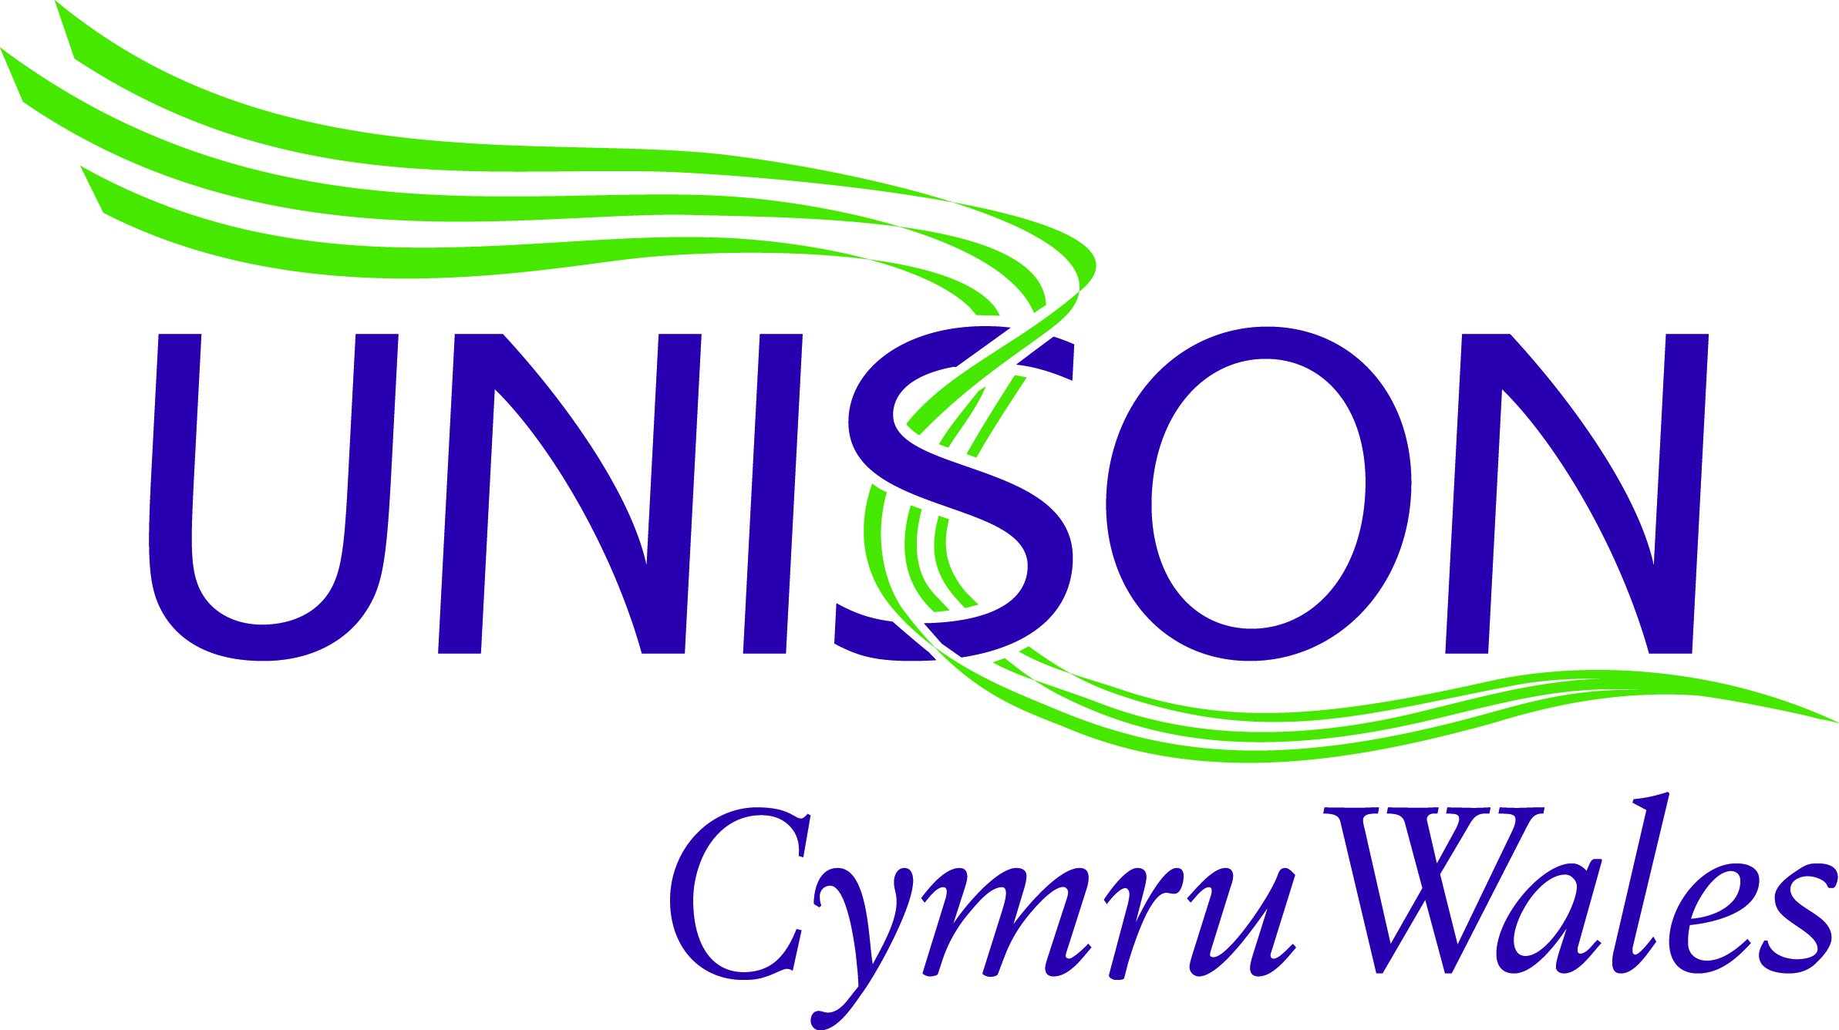
Our ref:

Your ref:

When telephoning please ask for:
UNISON House
Custom House Street
Cardiff
CF10 1AP

Tel: 0800 0 857 857
Web: cymru-wales.unison.org.uk
Email: cymruwales@unison.co.uk

24st September 2020

For the attention of:
Vaughan Gething, Minister for Health and Social Services

Welsh Government
5th Floor
Tŷ Hywel
Cardiff Bay
CF99 1NA

Dear Minister for Health and Social Services,

The true value of public services has never been more apparent than during the current ongoing COVID19 pandemic. Whilst many of us where able to take refuge from the virus in our homes, health care workers stared the virus in the face and worked tirelessly to keep the wheels of the NHS turning.

At the beginning of the crisis the fear was tangible. Maintaining the supplies of PPE to meet the surge in demand was a huge challenge. We had no idea how dangerous the virus was and many, including healthcare workers, have sadly lost their lives.

The dedication and commitment of NHS staff has been plain to see. For ten weeks communities across the UK united on the doorstep to applaud key workers for their invaluable work - a small but powerful display of appreciation.

Now is the time for health workers to receive proper recognition for the role they have played. Trade unions are urging the UK government to provide funding for a fair and early pay rise for all NHS staff.

A fair wage increase would help staff feel valued after the huge pressures and challenges faced in recent months. There would also be a boost to the economy as health workers spend the extra money in their pockets on local high streets.

Improvements to staff pay would enable the NHS to hold onto experienced workers – including many who’ve returned to its service during the pandemic. An early rise would help with the recruitment of new staff needed to fill vacancies across wards, teams, departments and clinics.

Yet the rhetoric from Westminster is already turning towards cuts to welfare and public sector pay.

We fully realise that the Welsh government is, to a large degree, beholden to the UK government on issues such as providing funding for a pay increase for NHS Wales workers.

We are therefore writing to ask you for two key actions which we believe will support our campaign for a fair and decent pay rise for NHS workers.

Firstly, we ask you to publicly add your voice to ours in calling on the Prime Minister and Chancellor to centrally fund a fair pay award for NHS workers. We have enclosed the joint trade union letters sent to both.

Secondly, we ask you to publicly commit to ring-fencing any consequential funding received from Westminster related to NHS pay in England, specifically for NHS pay in Wales.

Unfortunately, the struggle against this virus looks set to continue. The least we can do is ensure those on the frontline are properly rewarded for the vital work they do.

We look forward to hearing from you.

Yours sincerely,

Paul Summers - UNISON Cymru Wales Health Lead & Chair of Wales Business Committee Staff Side

Dawn Ward - Chair of UNISON Cymru Wales Health Care Committee

